Decision Tree Classifier Building in Scikit-learn

Importing Required Libraries
Let's first load the required libraries.
# Load libraries
import pandas as pd
from sklearn.tree import DecisionTreeClassifier # Import Decision Tree Classifier
from sklearn.model_selection import train_test_split # Import train_test_split function
from sklearn import metrics #Import scikit-learn metrics module for accuracy calculation

Loading Data
Let's first load the required Pima Indian Diabetes dataset using pandas' read CSV function. You can download the data here.
col_names = ['pregnant', 'glucose', 'bp', 'skin', 'insulin', 'bmi', 'pedigree', 'age', 'label']
# load dataset
pima = pd.read_csv("pima-indians-diabetes.csv", header=None, names=col_names)
pima.head()
 | pregnant | glucose | bp | skin | insulin | bmi | pedigree | age | label
0 | 6 | 148 | 72 | 35 | 0 | 33.6 | 0.627 | 50 | 1
1 | 1 | 85 | 66 | 29 | 0 | 26.6 | 0.351 | 31 | 0
2 | 8 | 183 | 64 | 0 | 0 | 23.3 | 0.672 | 32 | 1
3 | 1 | 89 | 66 | 23 | 94 | 28.1 | 0.167 | 21 | 0
4 | 0 | 137 | 40 | 35 | 168 | 43.1 | 2.288 | 33 | 1

Feature Selection
Here, you need to divide given columns into two types of variables dependent(or target variable) and independent variable(or feature variables).
#split dataset in features and target variable
feature_cols = ['pregnant', 'insulin', 'bmi', 'age','glucose','bp','pedigree']
X = pima[feature_cols] # Features
y = pima.label # Target variable

Splitting Data
To understand model performance, dividing the dataset into a training set and a test set is a good strategy.
Let's split the dataset by using function train_test_split(). You need to pass 3 parameters features, target, and test_set size.
# Split dataset into training set and test set
X_train, X_test, y_train, y_test = train_test_split(X, y, test_size=0.3, random_state=1) # 70% training and 30% test

Building Decision Tree Model
Let's create a Decision Tree Model using Scikit-learn.
# Create Decision Tree classifer object
clf = DecisionTreeClassifier()

# Train Decision Tree Classifer
clf = clf.fit(X_train,y_train)

#Predict the response for test dataset
y_pred = clf.predict(X_test)

Evaluating Model
Let's estimate, how accurately the classifier or model can predict the type of cultivars.
Accuracy can be computed by comparing actual test set values and predicted values.
# Model Accuracy, how often is the classifier correct?
print("Accuracy:",metrics.accuracy_score(y_test, y_pred))
Accuracy: 0.6753246753246753
Well, you got a classification rate of 67.53%, considered as good accuracy. You can improve this accuracy by tuning the parameters in the Decision Tree Algorithm.

Visualizing Decision Trees
You can use Scikit-learn's export_graphviz function for display the tree within a Jupyter notebook. For plotting tree, you also need to install graphviz and pydotplus.
pip install graphviz
pip install pydotplus
export_graphviz function converts decision tree classifier into dot file and pydotplus convert this dot file to png or displayable form on Jupyter.
from sklearn.tree import export_graphviz
from sklearn.externals.six import StringIO
from IPython.display import Image
import pydotplus

dot_data = StringIO()
export_graphviz(clf, out_file=dot_data,
filled=True, rounded=True,
special_characters=True,feature_names = feature_cols,class_names=['0','1'])
graph = pydotplus.graph_from_dot_data(dot_data.getvalue())
graph.write_png('diabetes.png')
Image(graph.create_png())
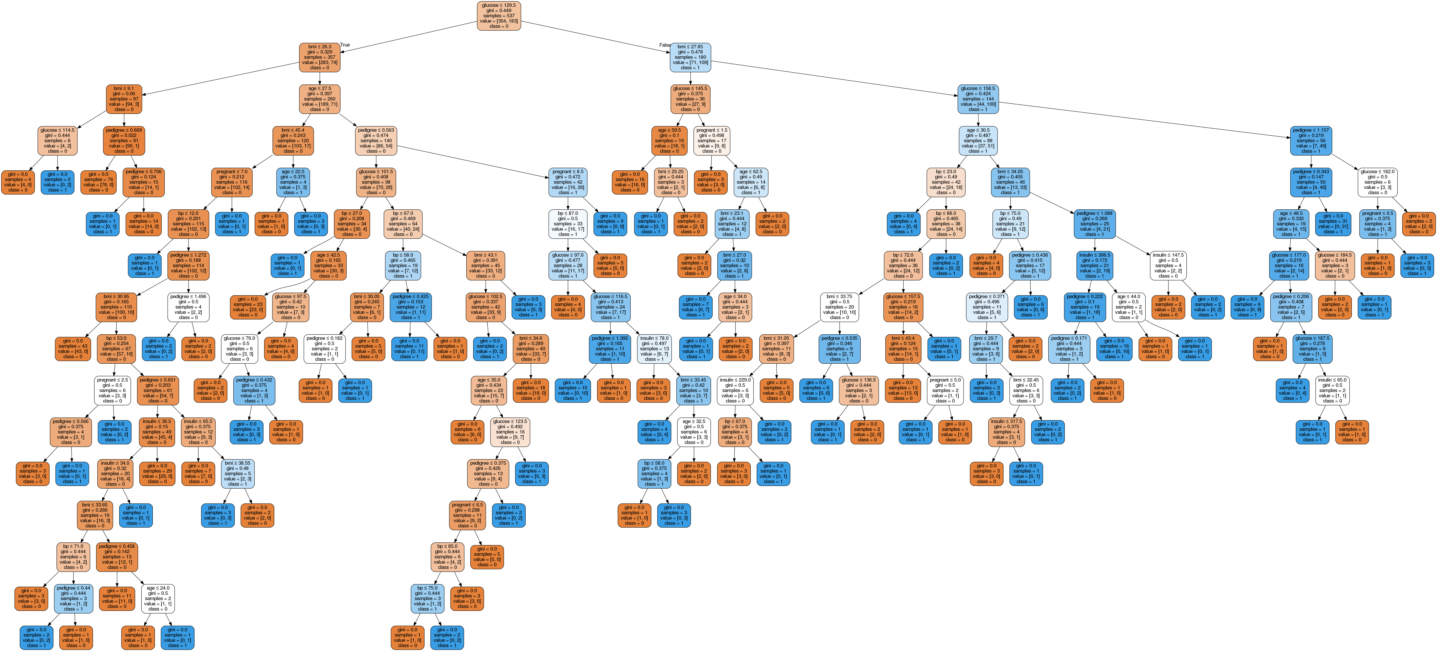
In the decision tree chart, each internal node has a decision rule that splits the data. Gini referred as Gini ratio, which measures the impurity of the node. You can say a node is pure when all of its records belong to the same class, such nodes known as the leaf node.
Here, the resultant tree is unpruned. This unpruned tree is unexplainable and not easy to understand. In the next section, let's optimize it by pruning.

Optimizing Decision Tree Performance
- criterion : optional (default=”gini”) or Choose attribute selection measure: This parameter allows us to use the different-different attribute selection measure. Supported criteria are “gini” for the Gini index and “entropy” for the information gain.
- splitter : string, optional (default=”best”) or Split Strategy: This parameter allows us to choose the split strategy. Supported strategies are “best” to choose the best split and “random” to choose the best random split.
- max_depth : int or None, optional (default=None) or Maximum Depth of a Tree: The maximum depth of the tree. If None, then nodes are expanded until all the leaves contain less than min_samples_split samples. The higher value of maximum depth causes overfitting, and a lower value causes underfitting (Source).
In Scikit-learn, optimization of decision tree classifier performed by only pre-pruning. Maximum depth of the tree can be used as a control variable for pre-pruning. In the following the example, you can plot a decision tree on the same data with max_depth=3. Other than pre-pruning parameters, You can also try other attribute selection measure such as entropy.
# Create Decision Tree classifer object
clf = DecisionTreeClassifier(criterion="entropy", max_depth=3)

# Train Decision Tree Classifer
clf = clf.fit(X_train,y_train)

#Predict the response for test dataset
y_pred = clf.predict(X_test)

# Model Accuracy, how often is the classifier correct?
print("Accuracy:",metrics.accuracy_score(y_test, y_pred))
Accuracy: 0.7705627705627706
Well, the classification rate increased to 77.05%, which is better accuracy than the previous model.

Visualizing Decision Trees
from sklearn.externals.six import StringIO
from IPython.display import Image
from sklearn.tree import export_graphviz
import pydotplus
dot_data = StringIO()
export_graphviz(clf, out_file=dot_data,
filled=True, rounded=True,
special_characters=True, feature_names = feature_cols,class_names=['0','1'])
graph = pydotplus.graph_from_dot_data(dot_data.getvalue())
graph.write_png('diabetes.png')
Image(graph.create_png())
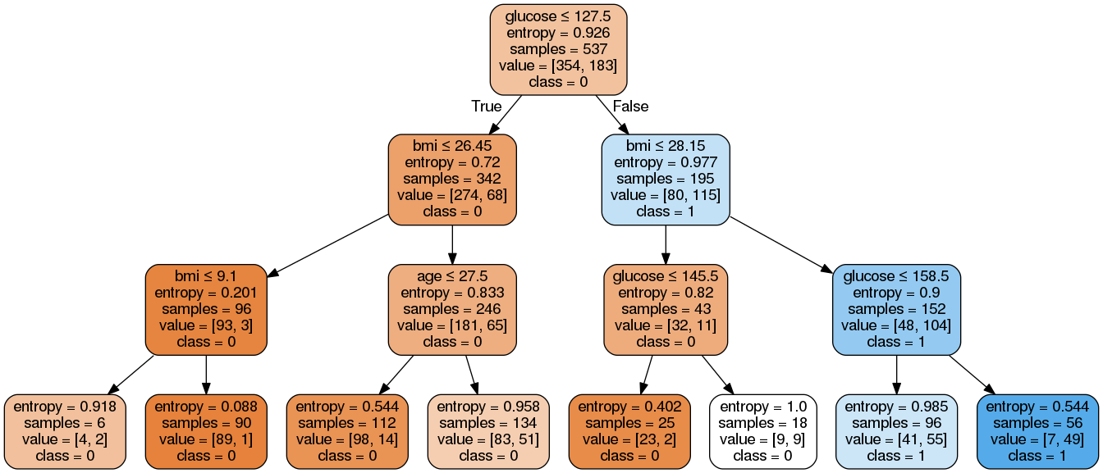
This pruned model is less complex, explainable, and easy to understand than the previous decision tree model plot.

